LAB1

This lab contains a set of instructions for getting familiar with the basics of Google Cloud and Cloud console.

Firstly, we start the lab by hitting Start button which builds a temporary environment in Google Cloud and the timer begins.

Open Google console Button opens the cloud console which is the web console and development hub for the Google cloud in which we can see our Google Cloud project. A Project ID is a unique identifier that is used to link Google Cloud resources and APIs to the specific project.

After this we need to sign in to the cloud and for this we need to use the username and password which is in the Connection Details pane at the left side under open console button. This takes us to the cloud in the new window in which we can see all the resources and services. Also, we can see the project info as in the screenshot:

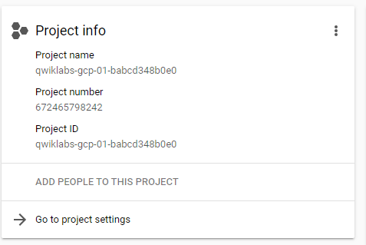

Moreover, we can view all our projects by click on the drop down menu next to name of project in the title bar which shows a box Select the project and then clicking on all gives us all the projects.

On the top left in the title bar, we have button clicking on which opens the navigation menu that provides quick access to the Google Cloud core services. There are 7 categories of services which include Compute, Storage, Networking, Cloud operations, Tools, Big data, Artificial Intelligence.

We can also view the roles and permissions by clicking on IAM & Admin in navigation menu which opens a page containing list of users and specifies the permissions and roles granted to each of them and we can also find our ‘qwiklabs’ username over there.

After that, we have APIs (application programming interfaces). To view that, we can simply go to APIs & Services then library. In this we have different categories available. We need to enable the APIs and for that we search for Dialogflow API and the page opens which contains option to enable and to enable it we need to click on that option. For confirming, we need to go back and the following windows appear which shows API enabled.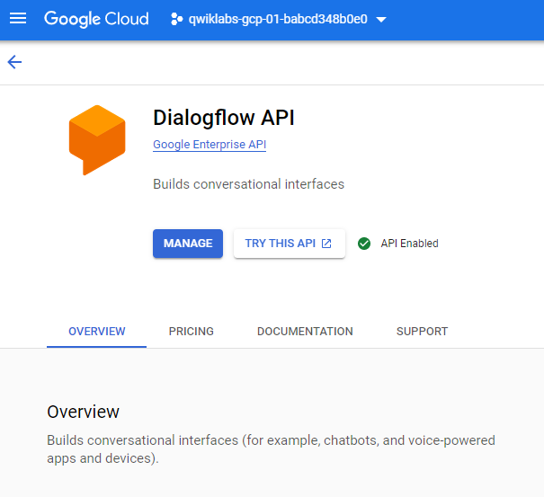

Then at last to return to the main page we can just click on navigation menu and then go to Cloud overview.

CERTIFICATE OF COMPLETION:

